Tri-R Distributing Inc
PO Box 98
Matteson IL 60443-0098
P: 708.534.2222 800.747.6457
F: 708.534.2223 sales@tri-rdistributing.com
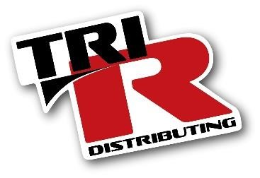
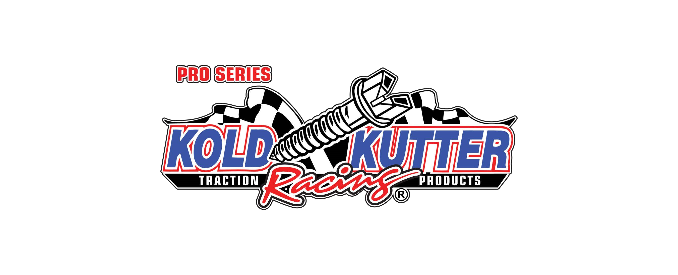
Dealer Application Request (return the completed form to us at one of the above methods)
Date:
Company Name:
Shipping Address:
City: |  | State: | Zip:
PH: |  | E-Mail:
Order Contact:
Years in Business: |  | At Current Location:
Business Hours:
Federal ID Number:
State Reseller Number:
Trade Suppliers  Company Name | E-mail / Fax | Acc# | Terms
Application completed by (sign here):
Tri-R Distributing Inc. has the right to refuse shipping of products if buyer is Past Due on any undisputed invoices owed to Tri-R. In the event that an undisputed invoice is not paid within 30 days, Tri-R Distributing Inc. will reach out to the buyer and notify of the default in writing. Upon receiving written notice, buyer will then have ten (10) days to cure the debt. In the event the buyer fails to cure the undisputed invoice within the cure period, Tri-R Distributing Inc. may then apply a finance charge of 1.5% per month until said amount is satisfied. In the event of any proceeding between the parties in connection with this application, the prevailing party will be entitled to recover its reasonable attorney fees and costs in such proceeding from the other party.
pg 1/2
Tri-R Distributing Inc. Dealer Open Account Application
IF REQUESTING OPEN ACCOUNT, THE FOLLOWING INFORMATION MUST BE FILLED OUT COMPLETELY
Corporation: Partnership: Sole Proprietorship:

If a corporation, list names of officers and titles, if other entity, list names of partners or owners
Name/Title Home Address Home Ph:

Officer(s) Signature / Title Driver Lic. Number

Terms of Account
- The standard credit terms granted are net 30 days. The company agrees to pay all undisputed fees listed on the monthly statement in full by terms stated on invoice, as modified herein.
- In the event of default of the foregoing paragraph, upon written notice and upon the grant of a cure period, which goes uncured, Company agrees to pay a service charge of 1.5% per month added monthly to all unpaid, undisputed, and uncured invoices.
- The company agrees to notify Tri-R Distributing Inc. of any changes in ownership within 30 days of said changes.
- If the account is placed for collection, and litigation ensued, the prevailing party will be entitled to their attorney’s fees and costs from the non-prevailing party.
Authorization to Release Information
I hereby authorize you to release any information necessary to assist in establishing a line of credit.
Banking Name: | Contact:
Account Number:
Address
City, State, Zip
All information is understood and agreed upon for establishing Open Account status.
Authorized by (please print)
Signed
Title: | Date:
Office Use Only Dealer Number: | Approved: | Declined:
pg 2/2

